**Instruction for Use**

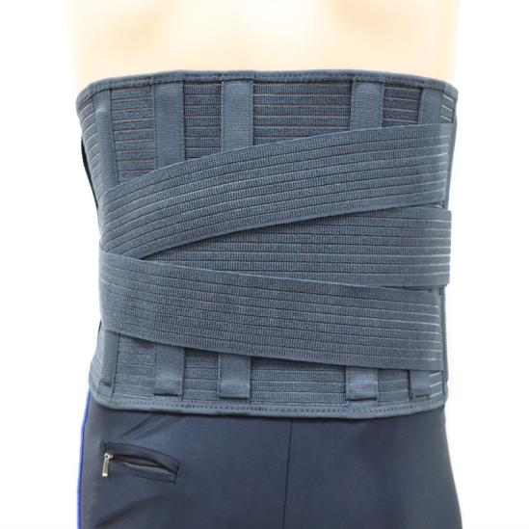

**Common Examples of Use**

**Suitable for lumbosacral soft tissue injury.**

**Suitable for fixation and adjuvant treatment of lumbar facet joint disorder, lumbar intervertebral herniation and prolapse, compression fracture, etc.**

**Suitable for the treatment of lumbar hyperosteogeny, acute and chronic lumbar injury, conservative treatment of lumbar intervertebral disc herniation or the protection of the waist after surgery is particularly effective, it is also the best protection for people who work under long-term stress in the waist**

**WARNING:**

**This product should be given by an treating doctor and applied by a professional. Application should be done with great care to ensure correct fit and efficiency of the brace. For hygiene reasons, it is proposed to be used by a single patient. Recommended product use up to 2 years.**

**WASHING INSTRUCTIONS:**

Check the condition of the product before use. If it is worn off, it needs replacement.

Hand wash with cold water. Use a soft detergent and remove the pads.

Allow to dry on its own. Do not wash it in a washing machine or dry it in a tumble dryer.